五年级Unit 6
学习目标 | 字母组合wh，发音为/w/；但是当wh后面是o时，则要发另一种音/h/

- 根据图片回答问题。
- What is WuYifang doing? 

- What is Chen Jie doing? 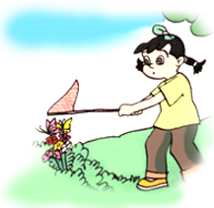

- What is Mike doing? 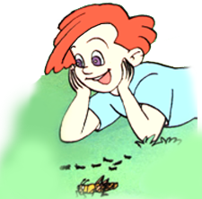

- What is Sarah doing? 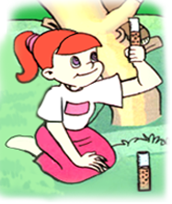

- What is Zhang Peng doing? 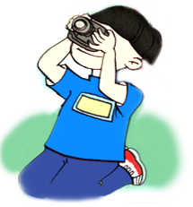

- What are they doing? 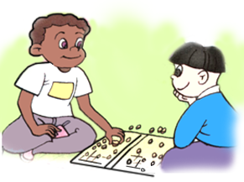

- What are you doing? 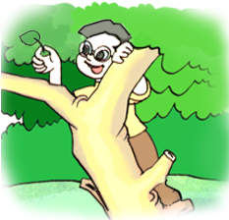

- What is he doing? 

- What is she doing? 

- What is Mike and Chen Jie doing? 

- 根据答句写出正确的问句。

- ______________________________________________________________
Tom is watching the insects.

- _______________________________________________________________
I am writing an report.

- ________________________________________________________________
They are collecting leaves.

- _________________________________________________________________
No, they are not doing an experiment.

- __________________________________________________________________
Yes, they are catching butterflies.

6. ___________________________________________________________________
Yes, I am taking pictures.

7. ___________________________________________________________________
No, he isn’t picking up leaves.

8. ___________________________________________________________________
They are in the woods.

9. __________________________________________________________________
Yes, the ants are eating the honey.

